Ross Lewis

Machine Learning

Homework 2

In this program, I load the data into memory, normalize all of the values, split it into training and test sets, perform gradient decent to retrieve the linear regression coefficients, and finally, test and visualize my model. For additional verification, I used the sklearn linear regression package to compare coefficients and found they match.

In the normalization step, for each column, I subtract the minimum value of the column and divide by the difference of the max and min. In the gradient decent step, I calculated the gradient with both the iterative process and with vector products. It seems the linear algebra method is easier in terms of implementation.

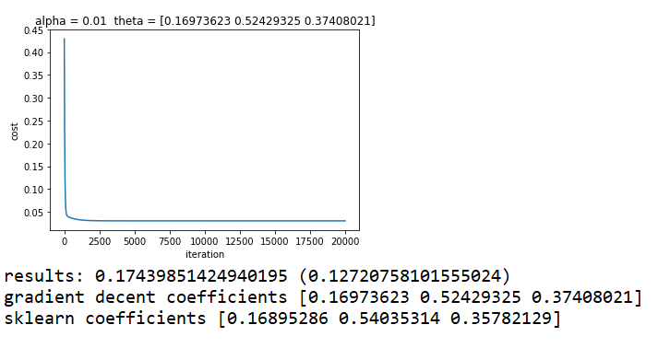

As you can see, the calculated coefficients are similar to the sklearn coefficients. They converged after a few thousand interactions which did not take long on my laptop. A higher alpha made the converge happen faster, but a lower value gave more precise coefficients. A lower iteration ran faster but had worse results.

The only thing the user will have to change to run this without error is the current working directory.

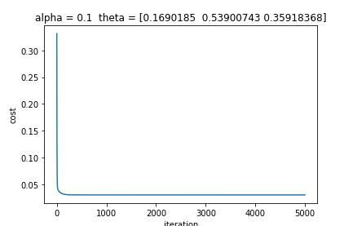

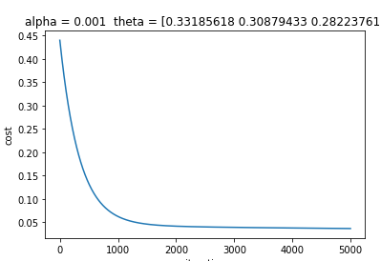

As you can see, with a smaller alpha, more iterations are required for convergence. The tradeoff is that more iterations take longer to run. A higher alpha also seems to be less accurate in it’s theta values for the same number of iterations.